User Manual
Standard Gaming Mouse

- System Requirements
- Windows XP/ Windows Vista /Windows 7 /Windows 8operating system
- Available USB(1.1/2.0) port
- CD-ROM
- 30 MB Available HARD DRIVE SPACE

- Installation
At First, connect your mice to PC,put the drive disk into PC,then follow the steps to install the game drive.
1. Open the driver installation file, and then double-click the following file icon, select the installation language.
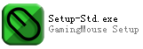
2.Click “Next”
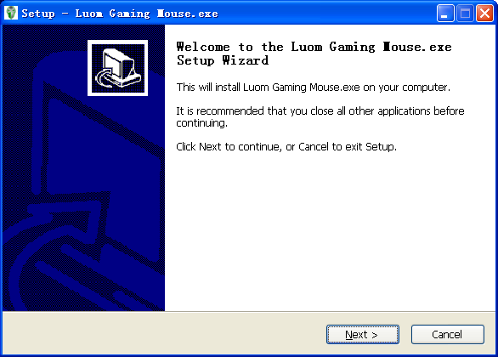
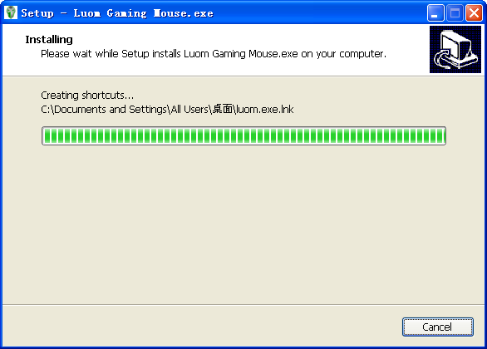

3.Check “Run luom.exe”,Start the program after installation，click“finish”Finish the installation
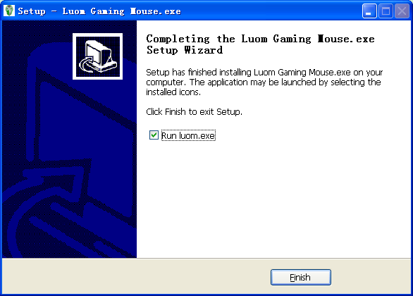

4.After installation, the program icon in the taskbar，Double-click the icon，Pop-up Settings interface program

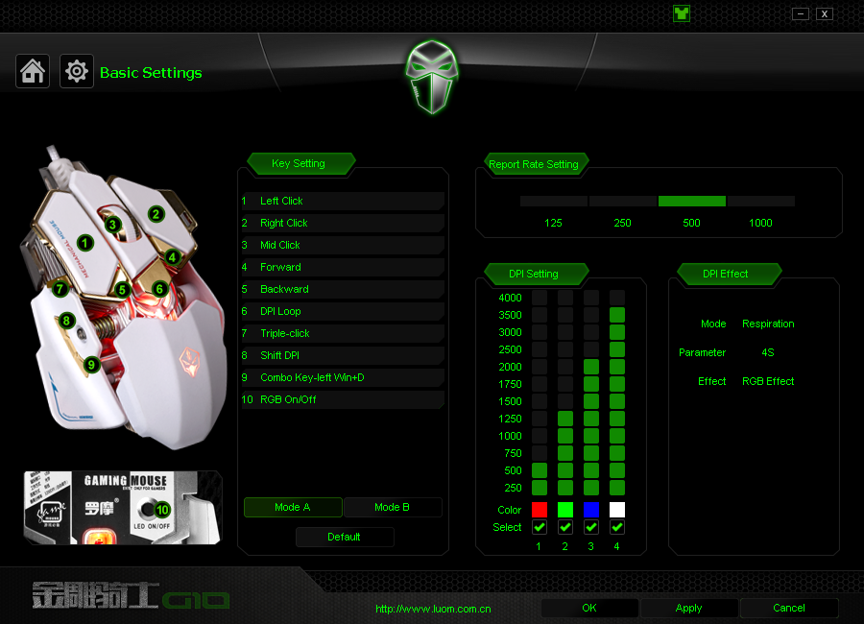

- Basic Settings
1. If you want to set 3 key as "Mid key" , you should click 3 key on Managing window at first,then double-click “Mid key”in the droplist.

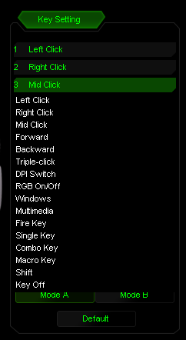

2.Configuration for 3 key as below

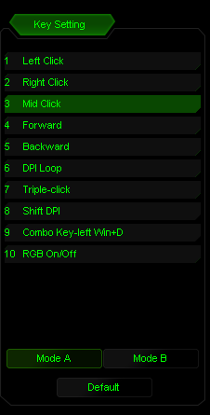

3.Click “Apply”,save settings



- “Single key” setting
1.If you want to set 4 key as "single key" , you should click 4 key on Managing page at first,then double-click “single key”in the droplist.

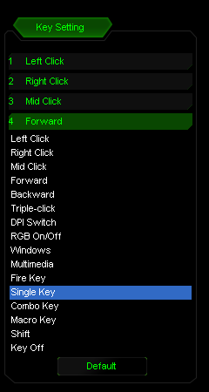
2.Popups is below，Input any key by keyboard as”Alt”,then click “OK”to close the window,save settings.
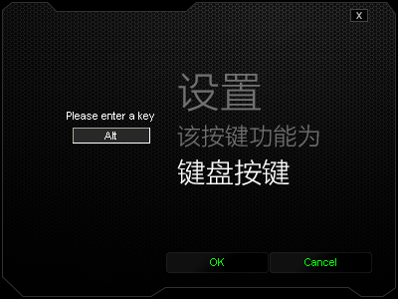

3.Configuration for 4 key as below
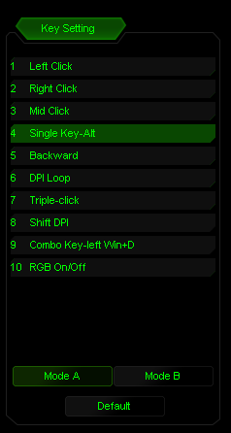
4.Click “Apply”,save settings

- "Fire key" setting
1.If you want to set 5 key as "Fire key" , you should click 5 key on Managing page at first,then double-click"Fire key" in the droplist.

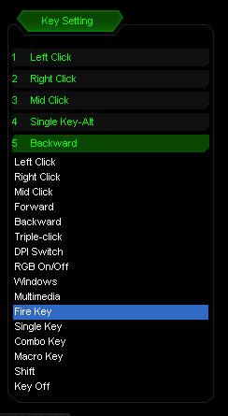

2.Popups is below，Input speed and times with keyboard or mice.Please refer to the following Introductions,then click “OK”to close the window,save settings.

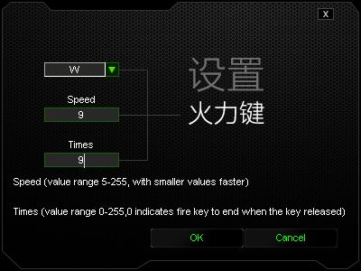

3.Configuration for 5 key as below
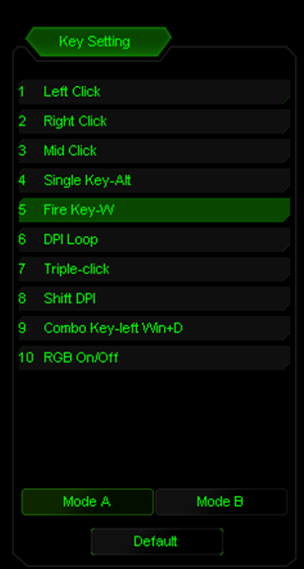
4.Click “Apply”,save settings

- ”Combo key”settings
1.If you want to set 4 key as “Combo key" , you should click 4 key on Managing page at first,then double-click"Combo key" in the droplist.

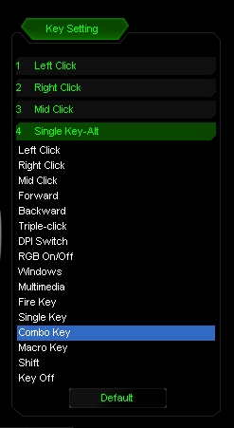
2.Popups is below，click Modify from droplist.Please input any key in edit box as below “Ctrl+A+Alt”,then click “OK”to close the window,save settings.

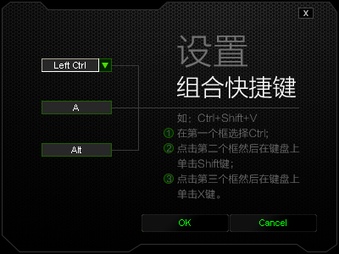

3.configuration for 4 key as below
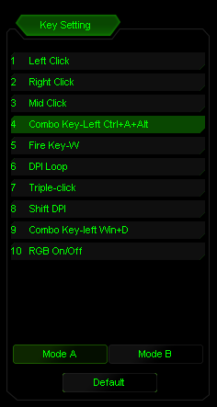

4.Click “Apply”,save settings

- Macro setting
1.If you want to set 5 key as macro,click “advance setting”option to set macro at first,input marco name in edit box.For example,input”1”as below show.click “new”,then click “start recording.”press a group of key from keyboard such as “shift+A+B”,then click “stop recording”,input number in “loop times” edit box to execute the macro order,then click “OK”to close save settings.

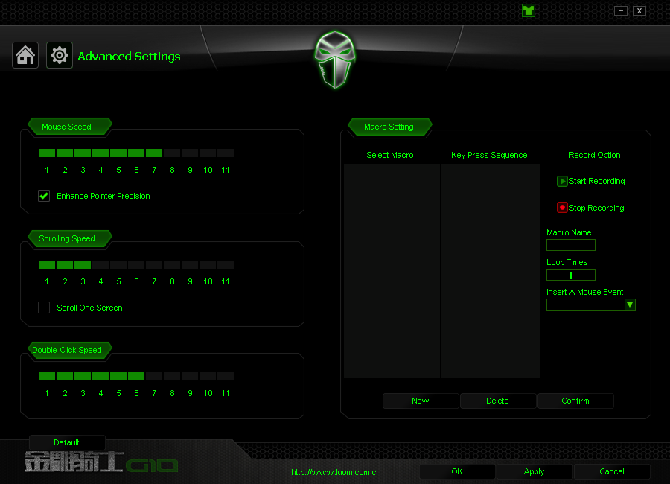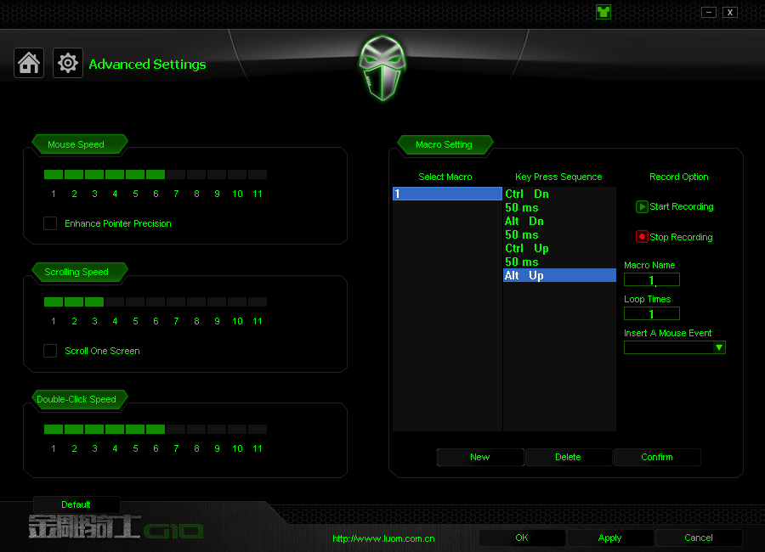

2.Click “basic settings ”option,click 5 key of Managing pages,then double-click “macro”in droplist.
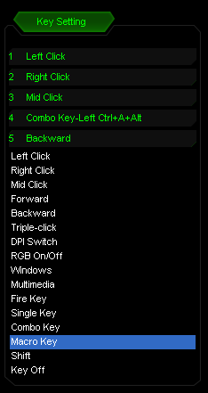
3.Popups is below，Input macro “1”,click one option to set from 3 groups in right.
then click “OK”to close the window,save settings.

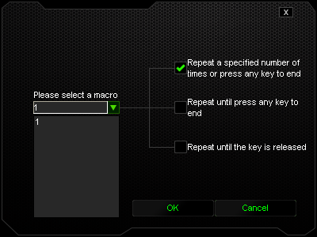

4.Configuration for 5 key as below
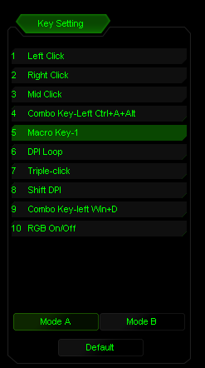
5.Click “Apply”,save settings

- Report Rate Setting
- Click “basic setting”,find below window,click different report rate.
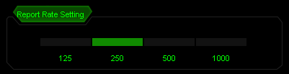

2.Click “Apply”,save settings

- DPI settings
1.Click “basic setting”,DPI setting is below,the picture shows four kinds of DPI switch,click color case to set dpi color.Moreover you can set dpi effect and parameter.
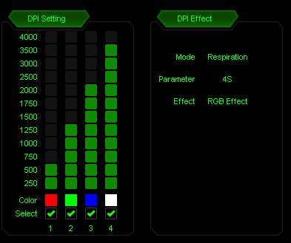
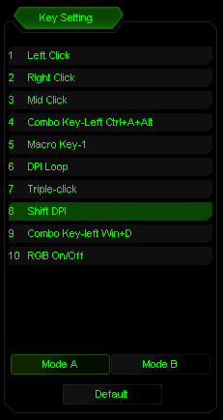
2.Click “Apply”,save settings

3.When you press 7 key,Bubble prompt window will be seen in System task bar,show the using DPI.
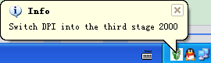

- Mouse Properties settings

1.Can adjust mouse speed,scrolling speed,double-click speed

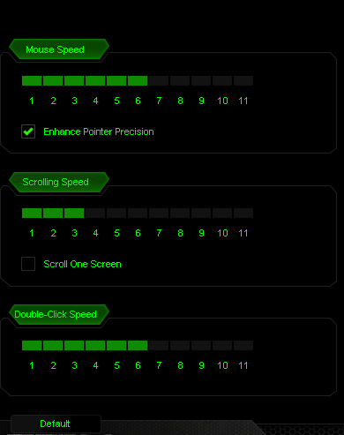

- Uninstall
1.Open Control Panel ,Open "add or remove programs" window,see “GamingMouse2.0”click “delete”,finish the uninstall program.

